**Warning: UE4SS is broken with U35. How to fix:**

1. Open UE4SS-settings.ini
2. Update the engine override settings MajorVersion and MinorVersion with the correct UE version of DRG (at the time of writing, this is 4.25). Would look something like this: A screenshot of a computer

   Description automatically generated with low confidence

**How to use UE4SS:**

1. Get your release from the [Github repo](https://github.com/UE4SS/UE4SS/releases)
2. Extract into the same folder that has the -Win64-Shipping.exe file
   1. For DRG, this is Deep Rock Galactic\FSD\Binaries\Win64
3. Launch the game, wait for the spacerig to load, and then inject the ue4ss.dll with whatever injector you use
   1. I use Cheat Engine, which you can get from [here](https://www.cheatengine.org/downloads.php) (be very careful when installing, as it will ask try to get you to install adware)
   2. To use CE, start the game and CE
   3. In CE, hit this little computer monitor button at the top under the File menu

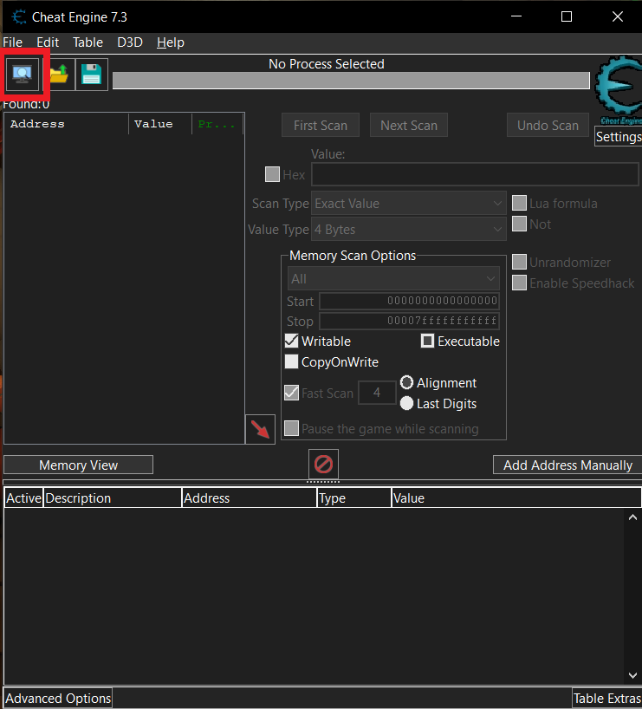

* 1. Go to the processes tab and find DRG, select it, then hit openA screenshot of a video game

     Description automatically generated with medium confidence
  2. Now hit the memory view button in the main UI
  3. Then go to the tools menu and hit inject DLL

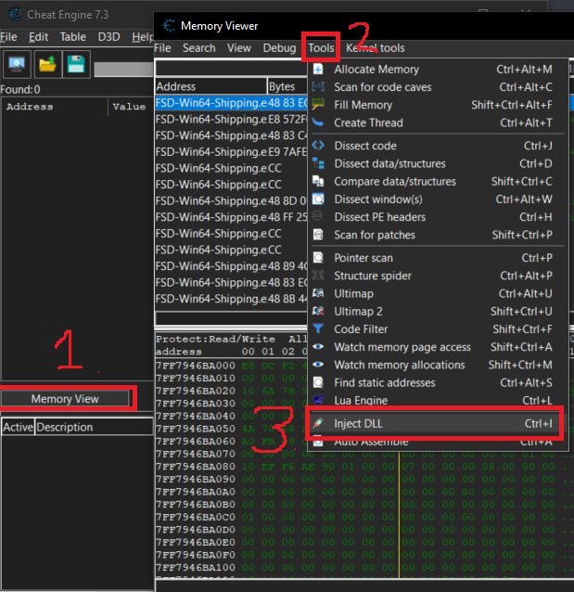

* 1. Then select ue4ss.dll
  2. A confirmation box asking if you want to execute a function of the dll will come up, press no

1. Now go back into the game, and wait a few seconds (as the program is aob scanning).
2. Then use F10 or the game’s default key to open console